Project Design Phase
Solution Architecture
Date | 30 September 2026
Team ID | MKU201Team66ab4dee00fc666a751b56cd7
Project Name | Script-Controlled ACL – Restrict Record Access Based on Field Value
Maximum Marks | 4 Marks
Solution Architecture:
Solution architecture is a complex process – with many sub-processes – that bridges the gap between business problems and technology solutions. Its goals are to:
- Find the best tech solution to solve existing business problems.
- Describe the structure, characteristics, behavior, and other aspects of the software to project stakeholders.
- Define features, development phases, and solution requirements.
- Provide specifications according to which the solution is defined, managed, and delivered.
Example - Solution Architecture Diagram:
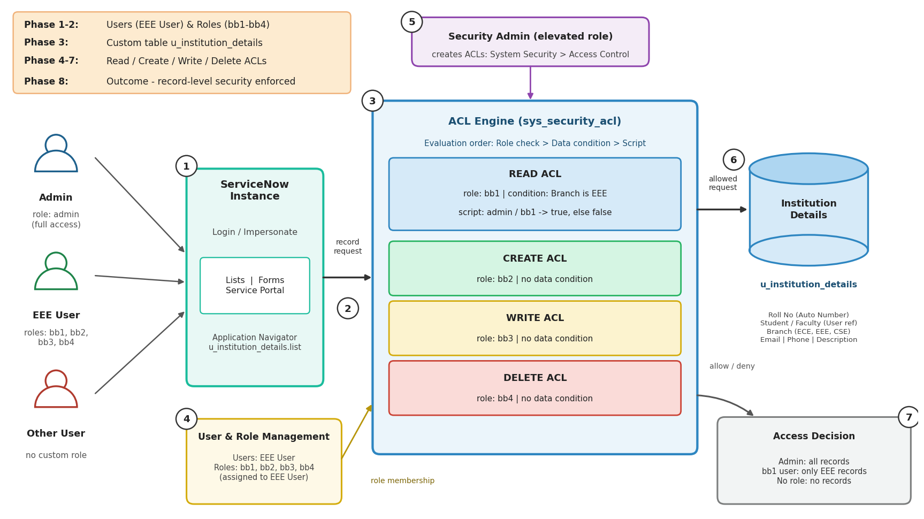
Figure 1: Architecture and data flow of the script-controlled ACL record-access application on ServiceNow
Reference: https://docs.servicenow.com/

